

**AMERICAN INTERNATIONAL UNIVERSITY–BANGLADESH (AIUB)**

**FACULTY OF SCIENCE & TECHNOLOGY**

**DEPARTMENT OF PHYSICS**

**PHYSICS LAB 3**

**Summer 2020-2021**

**Section: X , Group: 07**

**LAB REPORT ON**

***To determine the specific heat of a liquid by the method of cooling***

**Supervised By**

**Dr. Md. Nurul Kabir Bhuiyan**

**Submitted By**

|  |  |  |
| --- | --- | --- |
| **Name** | **ID** | **Contribution** |
| 1. **Md. Fahtin Emtiaz Onik** | **19-40471-1** | **Theory, Apparatus** |
| 1. **Nafinur Leo** | **20-42195-1** | **Procedure , Experimental Data** |
| 1. **S.M. Ashikur Rahman** | **20-42833-1** | **Graph, Discussion** |
| 1. **S.M. Hosney Arafat Rizon** | **20-43019-1** | **Calculation and Analysis** |
| 1. **Rad Shahmat Sabit** | **20-43610-1** | **Result, Reference** |

Date of Submission: **June 27, 2021**

**TABLE OF CONTENTS**

|  |  |
| --- | --- |
| **TOPICS** | ***Page no*.** |
| **i) Title Page** | 1 |
| **ii) Table of Content** | 2 |
| 1. **Introduction** | 3 |
| 1. **Apparatus** | 4 |
| 1. **Procedure** | 4 |
| 1. **Experimental Data** | 5 |
| 1. **Analysis and Calculation** | 6 |
| 1. **Result** | 7 |
| 1. **Discussion** | 7 |
| 1. **References** | 7 |

**1. Introduction**

The amount of heat, needed to increase the temperature of unit mass of a material by 1°C is called the specific heat of that material. It is denoted by S.

In the same environment, rate of change of cooling of an object is directly proportional to the difference of temperature between the object and the surrounding. This is the theory of cooling method. Difference of temperature of the object and the surrounding must be small. When a liquid is heated of higher temperature and placed to cool. Then the rate of heat lost by a temperature of the liquid is directly proportional to the difference in temperature of the surrounding.

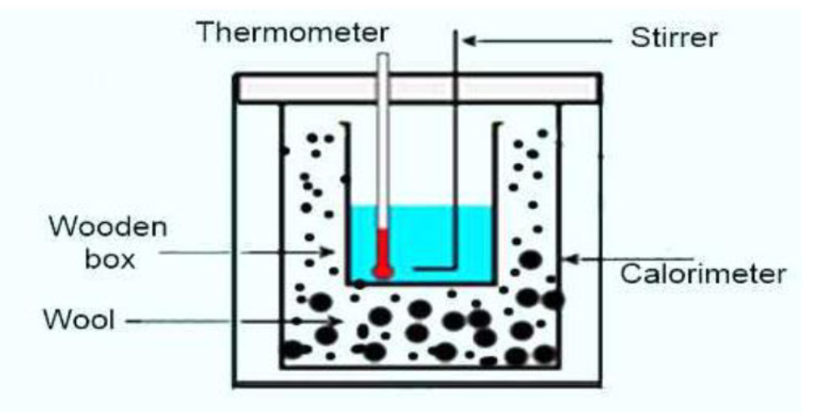

Suppose the mass of the calorimeter along with the stirrer = m kg

Mass of the experimental liquid in the calorimeter = M1 kg

Specific heat of the liquid = S1 J kg-1K-1

Time taken to cool the liquid from temperature- θ10 to θ20 = t1 sec

Mass of water having volume equal to that of the liquid = M2 kg

Specific heat of water = S2 J kg-1 K-1

Time taken to cool water from temperatures, θ10 to θ20 = t2 sec

So, rate of cooling of the liquid = [(M1S1 + mS) (θ1 – θ2)] / t1 Js-1

and rate of cooling of water = [(M2S2 + mS) (θ1 – θ2)] / t2 Js-1

According to Newton’s law of cooling, rate of cooling in these two cases is equal.

so, [(M1S1 + mS) (θ1 – θ2)] / t1 Js-1 = [(M2S2 + mS) (θ1 – θ2)] / t2 Js-1

or, [(M1S1 + mS) (θ1 – θ2)] / t1 = [(M2S2 + mS) (θ1 – θ2)] / t2

𝑆1=

**2. Apparatus**

(1) a calorimeter with a stirrer,

(2) a chamber having two walls,

(3) a sensitive thermometer,

(4) balance,

(5) burner,

(6) stop-watch etc.

**3. Procedure**

(1) Calorimeter has been taken of a clean and weight along with its stirrer.  
(2) Container is being heated by the water between temperatures of 70°A^C to 75°A^Cvand calorimeter is poured by that water to a fined mark. Two-walled chamber is being placed to this calorimeter.

(3) Water is being stirred slowly and slowly by a stirred and temperature of water is being recorded in 1°A^C internal. The temperature of water is decreased gradually as the temperature of water is more than room temperature. In this way 20 to 25 readings of temperature are recorded and then weight of the calorimeter along with water is taken. Weight of water is found out from the difference of these two readings weight.

(4) By calorimeter water was being thrown away. Then it was cleaned and dried by us. After that, experiment water liquid from 70°A^C to 75°A^C is poured in the calorimeter up to the previous mark. The liquid is being placed inside the chamber along with the calorimeter.

(5) Then the liquid is being stirred slowly and following procedure (3) Temperature is being recorded in each degree interval of temperature. 20-25 reading are being taken to this way. Afterwards calorimeter with liquid is being taken. The liquid is being found out from the difference of weights of 3rd and the first one weight.

**4. Experimental Data**

**Table: Time - Temperature record.**

|  |  |  |  |
| --- | --- | --- | --- |
| **No of. observation** | **Time (min)** | **Temperature (0C)** | |
| **Water** | **Liquid** |
| 1. | 0 | 65 | 68 |
| 2. | 1 | 63 | 65 |
| 3. | 2 | 62 | 64 |
| 4. | 3 | 61 | 63 |
| 5. | 4 | 60 | 61 |
| 6. | 5 | 59 | 60 |
| 7. | 6 | 58 | 59 |
| 8. | 7 | 57 | 58 |
| 9. | 8 | 56 | 57 |
| 10. | 9 | 55.5 | 56 |
| 11. | 10 | 55 | 55 |
| 12. | 12 | 54 | 53.5 |
| 13. | 14 | 52 | 52 |
| 14. | 16 | 51 | 50 |
| 15. | 18 | 50 | 49 |
| 16. | 20 | 49 | 47.5 |
| 17. | 22 | 48 | 46.5 |
| 18. | 24 | 47 | 45.5 |
| 19. | 26 | 46.5 | 44.5 |
| 20. | 28 | 45.5 | 44 |
| 21. | 30 | 45 | 43 |
| 22. | 33 | 43.5 | 41.5 |
| 23. | 36 | 42.542 | 40.5 |
| 24. | 39 | 41 | 39.5 |
| 25. | 42 | 40.5 | 38 |
| 26. | 45 | 40 | 37 |

**5. Analysis and Calculation**

Mass of the calorimeter + stirrer, m = 67.4 gm

Sp. heat of the material of the calorimeter, s = 0.0909 cal /gm- 0C

Mass of the calorimeter + stirrer +water, 𝑚2 = 152.2 gm

Mass of the water, 𝑀2 = 𝑚2−𝑚 = 84.8 gm

Mass of the calorimeter + stirrer +liquid, 𝑚1 = 150.5 gm

Mass of the liquid, 𝑀1 = 𝑚1−𝑚 = 83.1- gm.

𝑆1 = cal/g-oC  
 = 1.058 cal/g-0C

**6. Result**

Specific heat of given liquid = 1.058 cal/g -oC

**7. Discussion**

The chief source of error is due to evaporation of the liquid. To avoid this, we provided the calorimeter with a lid having holes for thermometer and a stirrer. We raised the temperature of water in the calorimeter above 70°C as in that case evaporation generally takes place from its surface and therefore law of cooling does not hold good then.

(1) Specific heat of given liquid is 1.058 cal/g -oC

(2) It was made sure that the pendulum oscillated in a vertical plane and so that there was no rotational motion of the pendulum. So, to keep the measurements accurate the calorimeter was kept clean and dry.

(3) If equal volumes of water and liquid were not taken then error would appear in the result. For that reason, same volume of water and liquid was taken.

(4) Calorimeter bottom was made black so that the heat radiation capacity would increase.

(5) Non-volatile liquid was taken.

(6) Calculations were determined carefully and accurately.

**8. Reference**

(i) Fundamental of physics: Resnick & Halliday

(ii) Practical physics: R. K. Shukla, Anchal Srivastava, New Age International (p) ltd,New Delhi

(iii) Zemansky, M.W. (1968) Heat and Thermodynamics